Contents

1. Executive Summary 3

2. Case for Change 4

3. Data: GCS Membership Profile 2022 5

4. Insight: Membership perspective 7

5. Connect, Learn, Grow: Building stronger GCS communities across the UK 9

6. Connect, Learn, Grow: Increasing GCS roles across the UK 10

7. Evaluation: How will we know we’re making a difference? 12

8. Annex: Delivery Timeline 13

9. References 14

1. Executive Summary

As government communicators, we speak to an incredibly diverse range of audiences across the UK and beyond. In order to understand local influences, motivation and behaviours, GCS must represent the local audiences we are engaging with. And as the world of communications and technology changes at pace, we must welcome diversity of thought and experience, so that we can collaborate in innovative ways.

That’s where you come in. GCS is full of talented, creative communicators and by building stronger GCS communities across the UK we can learn from each other, embrace new ways of thinking and lead the way in working across organisational boundaries.

It is vital to us that ​everyone in GCS can develop a rewarding career, wherever they work. Our Locations Strategy builds on the government’s Places for Growth programme to detail how we will grow communities of communicators across the UK. This strategy focuses on what we will do over the next two years. We will learn from our efforts and adapt what we do to continue to grow the community of people working in GCS in roles across the UK.

Over the next two years we will be focusing our activities on two clear objectives:

- Build stronger GCS communities across the UK
- Increase GCS roles outside of London

Through focus groups we have seen the energy, passion and expertise of GCS communicators based in cities around the country and the value of GCS comes through when we can bring this insight together. To connect our great people and attract new talent, we are establishing pilot GCS locations in Leeds, Manchester and Scotland (Glasgow and Edinburgh) to learn what works well when building a GCS community before rolling out further. We will work together as a leadership team to increase the number of GCS roles across the UK - including SCS - using the GCS data collection to hold ourselves accountable.

We are passionate about ensuring that GCS is a place where everyone can connect, learn and grow their careers. Read on to find out how this Locations Strategy will support you to do so.

Signed, cross-government Directors of Communications

2. Case for Change

Places for Growth is a government wide programme delivering on the UK Government’s commitment to move 22,000 Civil Service roles, and 50% of UK-based Senior Civil Service roles, out of Greater London by 2030. This will bring new jobs and investment to all parts of the UK, increase opportunities for people from a wider range of backgrounds, and help to grow a Civil Service with voices from beyond Westminster, reflecting the country it serves.

The GCS Strategy commits to creating GCS careers throughout the UK. This was further developed in our Equality Diversity and Inclusion Action Plan which emphasised that GCS communicators are the link between the government and UK citizens, delivering exceptional communications to explain the objectives and policies of the government and provide clarity and reassurance to the public. But, very simply, we will only understand our audiences and communicate effectively with people from across the UK when we draw on, and develop, talent from every community and from the widest possible range of geographical, social and career backgrounds. This GCS Locations Strategy builds on both commitments, outlining the importance of strengthening communities of communicators throughout the UK, so that everyone in GCS can develop a rewarding career regardless of where they live.

The government’s Levelling Up White Paper shows that social mobility in the UK is geographically segregated. There are significant opportunities for work and study in London and the south-east, but these are less prevalent in other areas. Research from the Social Mobility Commission demonstrates that people from a working-class background are less likely to migrate to London or other areas where more opportunities are available. Navigating the Labyrinth, a report into socio-economic background and career progression in the Civil Service, also highlights the ‘Whitehall effect’ as a barrier to social mobility, as proximity to Whitehall increases visibility and networking opportunities.

Levelling up means giving everyone the opportunity to flourish and this is what our Locations Strategy will do, connecting us together and with our audiences, supporting us to learn across different locations and organisations, and growing fulfilling communications careers and communities throughout the UK. As our GCS locations grow, so will our understanding of local audiences throughout the country, improving the communications we produce with innovative ideas and firsthand insight.

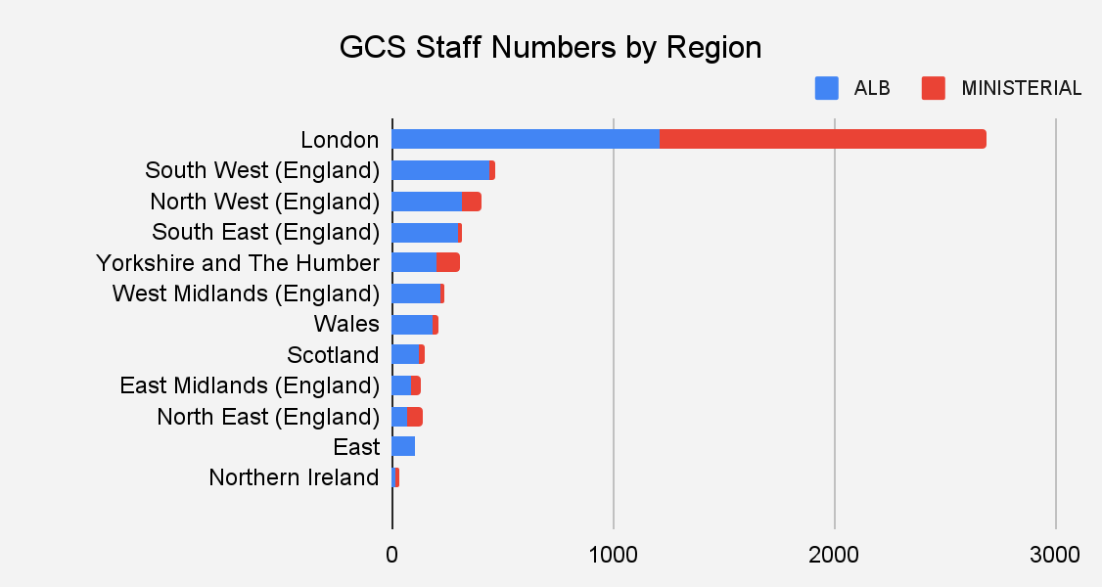
3. Data: GCS Membership Profile 2022

The 2022 GCS data collection identified more than 7,000 GCS members in seven disciplines, working across 346 government organisations and arms-length-bodies (ALBs).

52% of GCS members are based in London, 37% of those working in ALBs and 77% of those working in ministerial departments. 60% of GCS AA-EO roles are based outside of London, 49% of HEO/SEO roles, 36% of G7/G6 roles and 29% of SCS roles. Over 73% of GCS vacancies are advertised outside of London, with 76% being at HEO or above, providing opportunities for UK-wide progression.
Within GCS disciplines, Campaigns (56%), Design & Production (59%) and Internal Comms (60%) have a majority based outside of London. Conversely, 70% of Media and Press Office, 68% of Data and Insight and 62% of Marketing professionals are London based.

Feedback from senior leaders is that current needs for close proximity to ministers, and migration of skills to London have caused this London concentration of roles. The government’s Levelling Up White Paper highlights that this can cause a lack of adequate career progression for those who are not based in London. Increasing our geographic representation could support us to understand the needs of certain communities and how to reach them effectively.

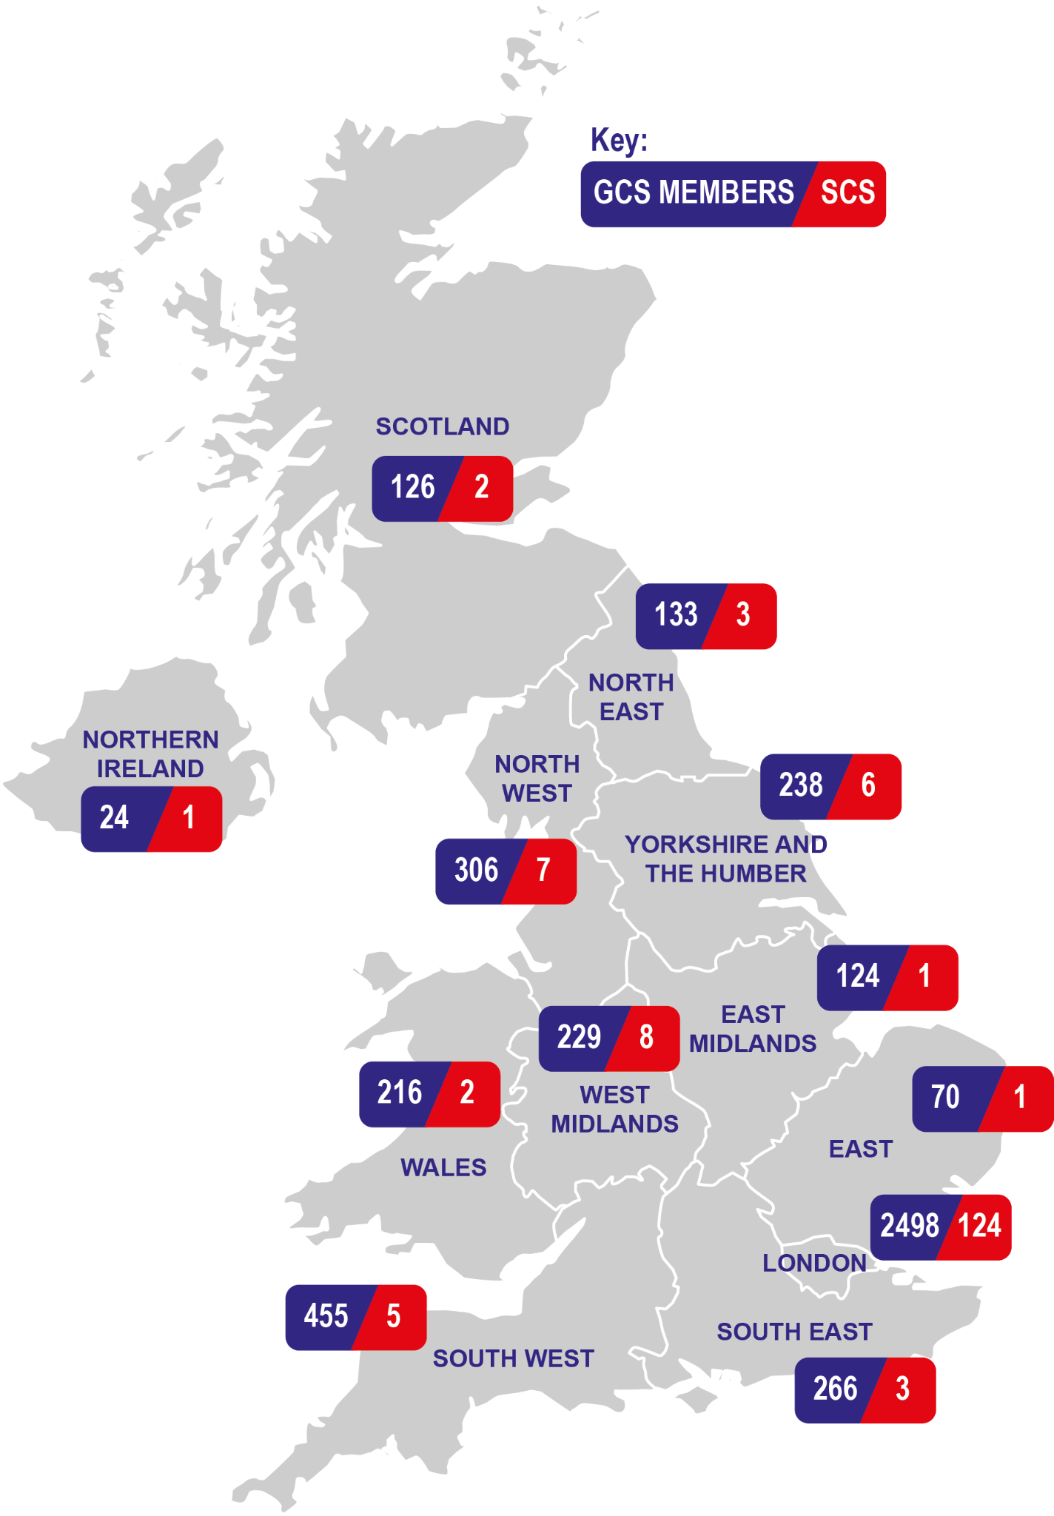
3. Data: Senior Civil Service GCS Profile 2022

There is SCS presence in every region of the UK, although outside of London, this is often in single figures. While there are 124 SCS based in London, there are eight in the West Midlands, seven in the North West and six in Yorkshire and the Humber. There is also SCS presence in each devolved nation. Physical proximity to Ministers and a traditionally London-based pipeline continue to drive SCS recruitment in London, with some SCS roles exclusively available to those located in London.

We currently have some SCS roles in social mobility ‘cold spots’ such as the North West and the West Midlands, although these are in the minority. As we progress with the strategy and disperse senior roles throughout the country, we should capitalise on the opportunity to facilitate social mobility by opening progression to senior grades to everyone, regardless of location.

The Levelling Up White Paper highlights regional skills differences throughout the UK, reinforced by the migration of highly educated and skilled people to London. Through outreach, by advertising regional roles through our GCS channels, and by equipping communicators with the skills they need through our L&D and talent offer, GCS Advance, GCS locations will attract local talent and provide the continuous learning required to develop a flourishing communications career throughout the UK.

4. Insight: Membership perspective
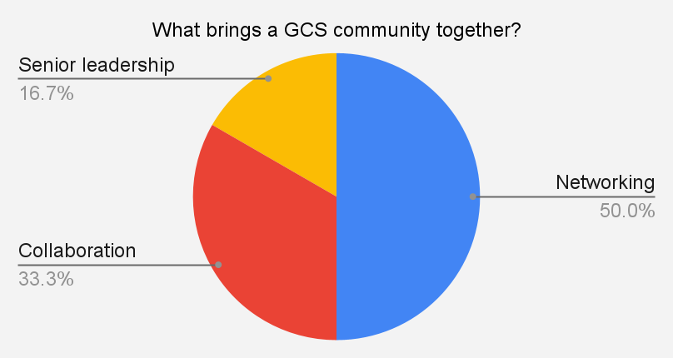
To understand the perspective of GCS members, we held 16 focus groups across all regions of the UK and conducted an online survey.

Only 7% of GCS communicators outside of London told us there is an existing comms ‘community’ in their location. Current barriers identified to building local comms communities include:
- Not knowing who is based in your location outside your department
- Lack of networking opportunities
- Low visibility of SCS outside of London
- A strong expectation that individuals must travel regularly to London, particularly problematic for those with caring responsibilities
For GCS members, a thriving ‘GCS location’ centres strongly on the concept of community. A GCS location must be a place where communication professionals can come together to network, learn and collaborate across organisations. Currently, a lack of visibility of who from other organisations are in the same region and little flexibility around local office spaces means that communicators are unable to meet-up, despite dozens being located in the same city. Contact with senior leadership and visibility of jobs are seen as key, supporting individual progression and a local GCS community to grow. All national regions expressed a perception of a lack of senior roles above Grade 7 available.

“There’s a vast improvement from where we’ve come…but those based in regional locations are isolated.”

Scotland focus group

“I don't know any other comms professional based in my region, so it’s hard to gauge whether there are opportunities in the area.”

Online survey participant
A focus on learning and development is also vital. Individuals highlight that mentoring, shadowing and local GCS events would provide greater opportunity for networking, collaboration across government and connection with GCS leaders. There is a strong desire that London-based SCS visit other GCS locations, to demonstrate their commitment to the Locations Strategy, and UK-wide GCS progression.
Wales Gov. Creative and Design Network: “The possibilities are endless, this is just the start”
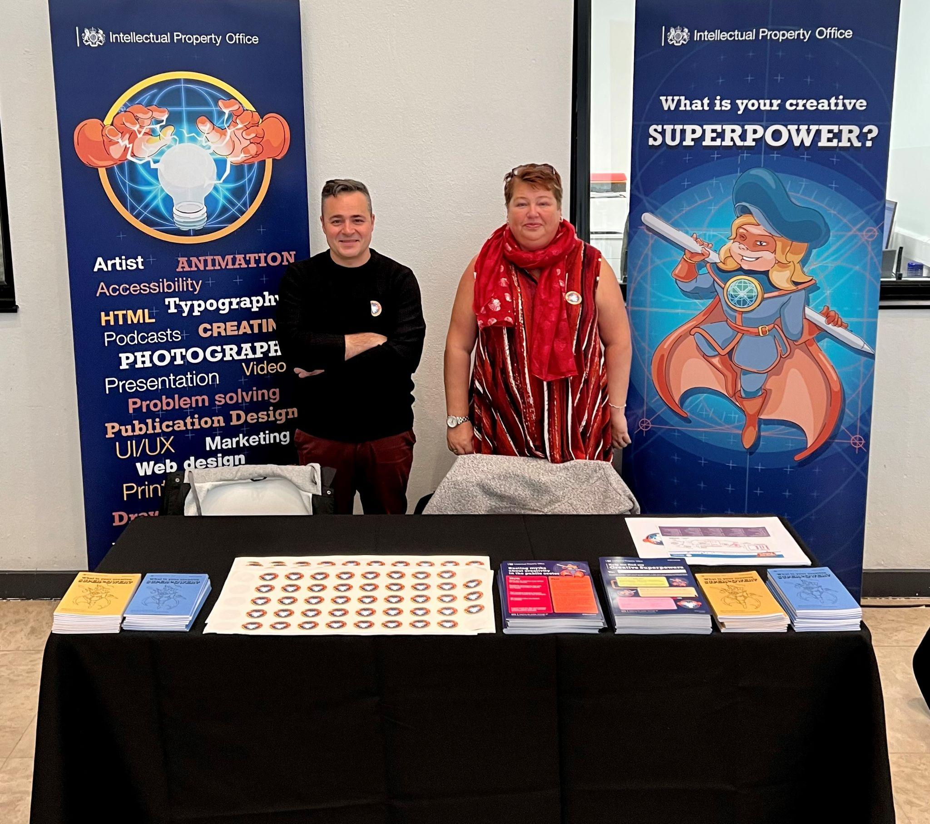
The Gov. Creative & Design Network is a design-led network for visual and applied designers across the Civil Service in Wales. The network aims to increase design standards and resources across the Civil Service in Wales, breaking institutional barriers to build a design community that exemplifies brilliant modern communications and embraces hybrid working.

Diverse: Powerful together
Curious: Brave enough to ask the right questions
Contribute: Design more with each other

Through ‘Creative Campfires’, the network shares common ambitions, ideas, and design practices. Heads of department meet regularly to share experiences and ideas. The IPO has shared its purpose built studio space with other local government creative teams: this offers a professional, fit for purpose space to use for photography and filming. To inspire a new generation of creative talent, the network attended a creative career event, launching an Instagram page to showcase creative talent in Wales.
Trade Remedies Authority: “We’re proud to be flying the flag for the Government’s presence outside of London”
Located along the newly created Elizabeth Line in Reading, the Trade Remedies Authority (TRA) is one of the government’s newest arm’s length bodies. Its purpose is to defend UK economic interests against unfair international trade practices. The TRA is a small but growing body of around 140 skilled professionals, with a 7 strong communications team.

The TRA is committed to building an organisational culture around the values of transparency, expertise, inclusion and integrity. In a recent staff survey, 82% of staff said they would recommend the TRA as a great place to work and the goal is to make the TRA an expert and innovative place where people enjoy working. While its proximity to London allows a closeness to central government colleagues, nearly half of staff live in Reading or the surrounding area, some from Wolverhampton and Cardiff.

The TRA is proud to be flying the flag for the Government’s presence outside of London and while trade investigations haven’t yet covered the three ‘Bs’ of Reading – beer, bulbs and biscuits – they’re staying in the area. The TRA also works closely with Reading University to facilitate student exchanges and plans to welcome a GCS apprentice in the autumn.

5. Connect, Learn, Grow: Building stronger GCS communities across the UK

The biggest action based on our insights is to build GCS regional networks and communities. GCS communities will enable local GCS members to connect, learn and collaborate, sharing opportunities and strengthening career pathways across the UK. This will improve our external communications by welcoming fresh ideas, perspectives and experiences directly from the communities we serve.

Based on your feedback about what makes a great comms community, each GCS location will be underpinned by the following principles:

- Central development of GCS Connect, so that individuals can identify and connect with local colleagues
- A local lead and SCS champion in each GCS location, to lead activities and be part of the regional Place for Growth working group
- GCS Outreach in local communities, to build visibility of GCS in the region, supporting social mobility by building a future pipeline of talented communicators, and improving our communications through better connection with local audiences
- Future GCS induction, GCS Advance and discipline events held in GCS locations, to provide networking and L&D opportunities
- Quarterly visits from GCS Senior Leaders, to increase UK-wide visibility

But, great communities are created by the people in them - your interests, energy, and ideas will shape what the GCS communities become.

Analysing data on where GCS members are currently based, where there is an established SCS presence and where there is a strong external market with media outlets and creative agencies, we have identified three pilot locations: Scotland (Glasgow and Edinburgh), Manchester and Leeds. We will run the pilots from Autumn 2023, and review what works well before rolling out further (delivery timeline in annex).

We recognise that there are lots of great GCS people in other locations. GCS Connect is a platform which everyone in GCS can use to connect with colleagues and we will provide a toolkit to support those in other locations to connect and build a local community.

6. Connect, Learn, Grow: Increasing GCS roles across the UK

Our focus will be on fostering strong GCS communities, where communications professionals want to be and can progress. To support the growth of these communities and the wider Places for Growth programme, we have two targets which we will work with departments to deliver.

- A third of all GCS roles in ministerial departments outside of London by 2025

Half of GCS members are already located outside of London, driven by our ALBs in which 63% of comms professionals work outside of London. Currently 77% of GCS roles in ministerial departments are London based and roles outside of London are concentrated at HEO/SEO level. While GCS locations will be inclusive of all GCS members, we will focus on increasing the number of Grade 7, Grade 6 and SCS roles in ministerial departments based outside of London. This is a commitment of all GCS leaders together to:

- Advertise GCS roles (including SCS) in ministerial departments in more than one location, unless there is an exemption
- Raise visibility of vacancies through local leads and SCS champions, through Civil Service Careers, and GCS channels
- Redefine our GCS talent offer to attract and build a diverse GCS and strong leadership pipeline across the UK

- Support the Places for Growth target of 50% of Civil Service SCS posts outside of London by 2030

As GCS communities grow, so will our pipeline of talented, regionally based communicators. To ensure that everyone, regardless of location, has the opportunity to progress to SCS, we need to remove cultural and perceptual barriers that currently prevent people working outside of London. Over the next two years we will:

- Champion the work being done by Places for Growth, to drive cultural change with ministers and Permanent Secretaries
- Share the cultural value of what we have learnt about hybrid working to reduce the requirement for SCS presence in London
- Work with SCS champions in pilot locations to identify effective search firms operating in that location, ensuring return on investment through targeted local market engagement to widen the pool of prospective candidates

Everyone in GCS should feel valued and able to progress regardless of location, both inside and outside of London. Through the annual GCS collection, we will analyse how the GCS landscape changes as we grow stronger communities and see what impact these actions have.
HMRC “Being based in the regions means that people understand local issues from a much more local point of view”
Around 70% of HMRC’s Communications team works outside of London, including 50% of SCS. The Director of Communications is based in the East Midlands and splits his time between there, London, and HMRC’s other regional centres. Recruiting across 13 locations has significantly increased the talent pool, with upwards of 100-250 applications for some roles advertised, and candidates with a more diverse range of talents and experience. HMRC Communications’ location strategy ensures each location has a mix of grades and disciplines, as recruitment is open across all regional locations. This results in close collaboration between teams in the communications community.

Communications colleagues are often located alongside those from other disciplines across HMRC which means they are better embedded into the organisation. The range of disciplines and teams within regions provides opportunities for sharing knowledge, best practice and career development opportunities, and content is often more relatable as colleagues based in regions better understand local and regional issues in the communities of which they are a part.

Historic England “Being ‘on the ground’ is helping to break down silos and lean into a more collaborative way of working”
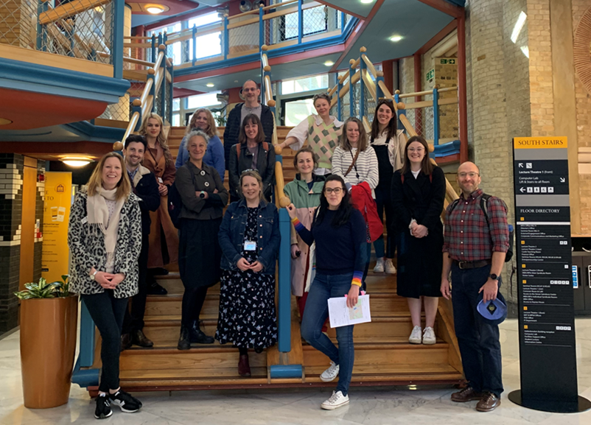
Historic England is a DCMS ALB aiming to improve people’s lives by championing and protecting the historic environment. The communications team has 17 people, seven in regional offices - Newcastle, Manchester, York, Birmingham, Cambridge and Bristol. ‘National roles’ can be done from any of those offices.

When English Heritage split into two organisations in 2015, Historic England focussed on building brand awareness. The Regional Public Engagement Team was created to develop influence and to build understanding of Historic England’s role and public value at a regional level. The team has developed a strong working relationship with local stakeholders and MPs. Being based in the Regions, Public Engagement Managers have developed a strong working relationship with the teams, helping Historic England rank 4th most reputable public sector organisation in RepTrak.

Internally, being embedded with regional teams helps to build trust and understanding of the communications’ contribution to achieving the organisation’s strategic aims. Being ‘on the ground’ is helping to break down silos and lean into a more collaborative way of working and colleagues in regional offices have informal relationships with peers in Arts Council England and National Lottery Heritage Fund, collaborating on day-to-day work.

7. Evaluation: How will we know we’re making a difference?

- Connect and Learn: Building stronger GCS communities across the UK

We will conduct local evaluation in our pilot GCS locations twelve months after they are established. In our pilot locations, our aim is that twelve months after a pilot locations has been launched:

- There is an increased ‘sense of community’ from 7% to 60%
- 60% feel that their local network has increased, supporting their development and sense of belonging
- 75% have taken part in a local L&D event
- 60% agree that there is greater visibility of roles in their region
- 75% agree that there is visible SCS support in their locations, supporting the community to grow

We will use the GCS data collection to identify growth in our GCS locations and inform where future GCS locations should be established.

- Grow: Increasing GCS posts across the UK

While growing GCS communities and driving cultural change will be our primary focus over the next two years, we will use the annual GCS data collection to analyse progress in increasing the percentage of roles across the UK:

- A third of all GCS roles in ministerial departments are based outside of London by 2025
- Support the Places for Growth target of 50% of Civil Service SCS posts outside of London by 2030

We will use data from GRS (Government Recruitment Service) to identify where communications roles are being advertised, so that we can understand where there are opportunities for progression throughout the UK, and whether they align with where GCS locations are growing. This will enable us to adjust our strategy to take further action where needed, and inform where future GCS locations will be.

8. Annex: Delivery Timeline
Preparing for Pilot
July - Sep 2023

Pilot
Sep 2023 - August 2024

Evaluation and Lessons Learnt
July - Sep 2024

Improve and Expand
Sep 2024 - August 2025

Evaluation and Lessons Learnt
July - Sep 2025

Long Term Strategy
September 2025

9. References

Government Communication Service: our strategy for 2022 to 2025

GCS Equality Diversity and Inclusion Action Plan

Social Mobility Commission: The Long Shadow of Deprivation

Social Mobility Commission: Navigating the Labyrinth

Social Mobility Commission: State of the Nation 2018 to 2019

UK Government: Levelling Up the United Kingdom

© Crown copyright 2023

This publication is licensed under the terms of the Open Government Licence v3.0 except where otherwise stated. To view this licence, visit nationalarchives.gov.uk/doc/open-government-licence/version/3

Where we have identified any third party copyright information you will need to obtain permission from the copyright holders concerned. Any enquiries or requests for alternative versions of this publication should be sent to gcs@cabinetoffice.gov.uk

Design by Tiffany Meyrick

The map on this page is based on the 2022 GCS data collection, in which only 66% of returns included Information on employee regional breakdown. We will use the 2023 GCS data collection to build our understanding of the picture and where GCS presence is growing.
As defined by the Social Mobility Commission, social mobility ‘cold spots’ are areas with fewer opportunities in education and employment.
This will also include exploring how we work with communicators in devolved administrations and how a GCS secondments strategy could open career development opportunities.

